LAB #09

Power of Continuous & Discrete time Signals, Application of Fourier Series, Synthesis of Waves,



Spring 2023

**CSE-301L Signals & Systems Lab**

Submitted by: MUHAMMAD SADEEQ

Registration No.: 21PWCSE2028

Section: C

“On my honor, as a student of the University of Engineering and Technology, I have neither given nor received unauthorized assistance on this academic work”

Submitted to:

Engr. Sumayyea

(2 June 2023)

Department of Computer systems engineering

University of Engineering and Technology, Peshawar

**Task 1**

**Code:**

|  |
| --- |
|  |
|  |
|  |
|  |
|  |
|  |
|  |
|  |
|  |
|  |
|  |

**Output:**

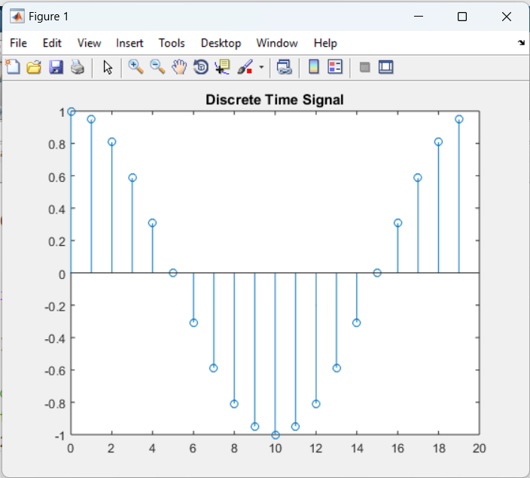

**Task 2**

**Code:**

|  |
| --- |
|  |
|  |
|  |
|  |
|  |
|  |
|  |
|  |
|  |
|  |
|  |

**Output:**

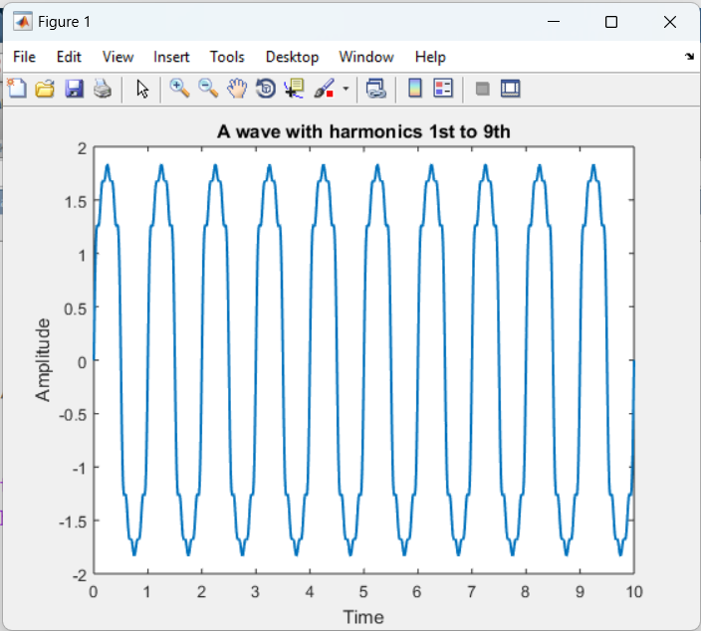

**Task 3**

**Code:**

|  |
| --- |
|  |
|  |
|  |
|  |
|  |
|  |
|  |
|  |
|  |
|  |
|  |

**Output:**

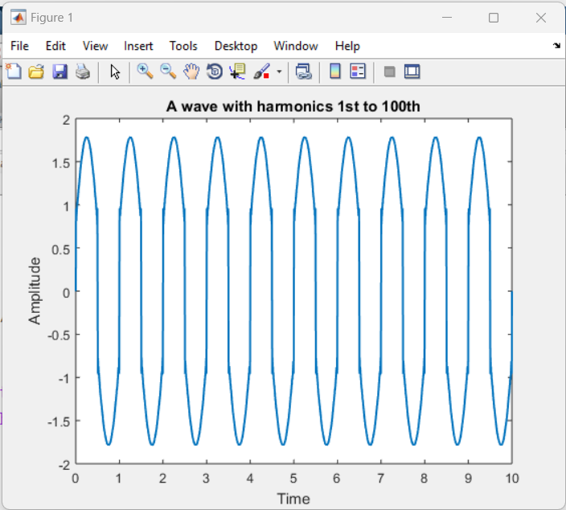

**Task 4**

**What do you conclude from TASKS 2 & 3?**

|  |
| --- |
|  |
|  |
|  |
|  |
|  |
|  |
|  |
|  |
|  |
|  |
|  |
|  |
|  |
|  |
|  |
|  |
|  |
|  |
|  |